SIMATS ENGINEERING
ASSESSMENT TOOL 1 - Concept Mapping

COURSE NAME: Data Structures COURSE CODE: CSA0311
Register Number | 192565020
Name | Y Guru Charan

COURSE OUTCOME COVERED

CO1: Apply suitable data structures and ADTs for efficient problem solving by analyzing time and space complexity. (BL2, BL3)

Assessment Tool Weightage: 35%

Questions:2 | EACH QUESTIONS CARRIES: 10 MARKS Total Marks:20 Duration: ONE HOUR
Q1 A smart healthcare system processes large volumes of patient data such as temperature readings, medical history, and diagnostic details. Construct a concept map linking the progression from Data → Data Object → Data Structure → Abstract Data Type (ADT) → Implementation in C. Identify relevant sub-concepts such as structures, pointers, and operations, and establish meaningful relationships among them. Organize the concept map hierarchically and justify how each level contributes to efficient data organization, processing, and improved system performance.
Q2 A smart city traffic management system handles data related to vehicle movement, road networks, and signal control. Construct a concept map connecting Primitive Data Structures → Non-Primitive Data Structures → Linear → Non-Linear Structures. Include examples such as arrays, linked lists, trees, and graphs, and illustrate their applications in traffic management. Explain the relationships between these structures and justify their classification based on functionality and efficiency.

Code of Conduct:

I (Y Guru Charan / 192565020) (Name / Reg No) certify that this submission is my original work and that I have adhered to the guidelines specified for this assessment.
I understand that any violation of academic integrity rules will result in disciplinary action.

Signature of the student:



RUBRICS FOR CALCULATION:

Concept Mapping
Criteria | Weightage | Level 4 (Exemplary) | Level 3 (Proficient) | Level 2 (Developing) | Level 1 (Beginning)
Concept Identification | 25% | Identifies all key concepts from literature accurately and comprehensively | Identifies most key concepts with minor omissions | Identifies limited concepts; some are irrelevant or missing | Fails to identify essential concepts
Linkages | 25% | Establishes clear, meaningful, and accurate relationships between concepts | Shows correct relationships with minor gaps | Relationships are weak, unclear, or partially incorrect | No meaningful relationships established
Organization | 20% | Concepts are well-structured hierarchically with logical flow and grouping | Mostly organized with minor structural issues | Some organization but lacks clear hierarchy | No logical organization or structure
Integration of Literature | 20% | Integrates multiple studies effectively to show connections and comparisons | Shows some integration of literature | Limited integration; mostly isolated concepts | No integration of literature evidence
Clarity | 10% | Concept map is clear, neat, visually structured, and easy to interpret | Generally clear with minor readability issues | Clarity is reduced; difficult to interpret in parts | Poorly presented and hard to understand

ANSWERS:

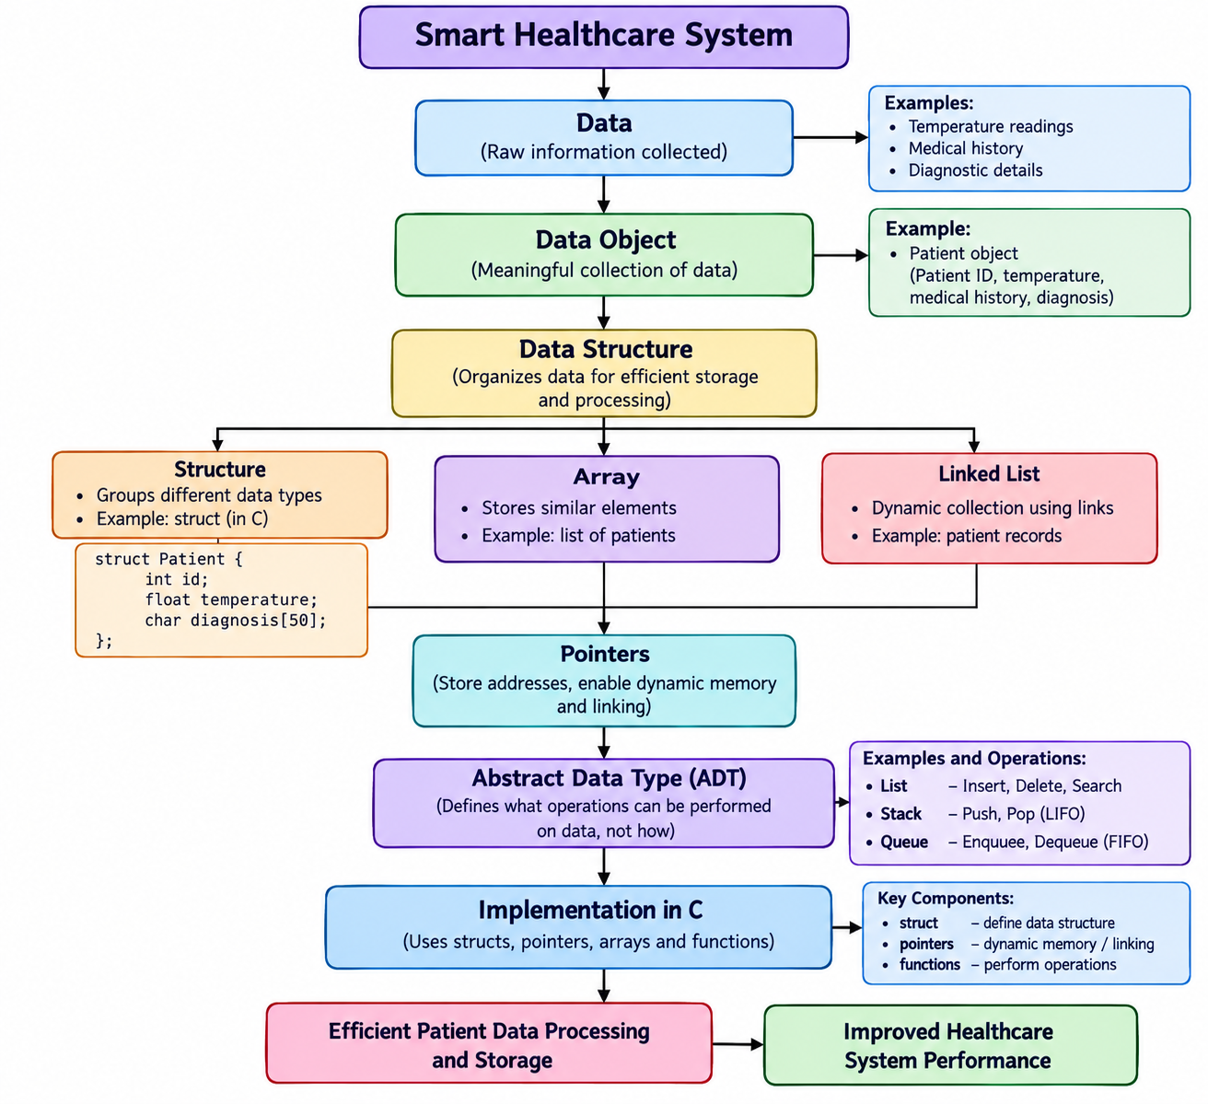

Data:
Data is the basic information collected by the healthcare system. In this system, examples include temperature readings, medical history and diagnostic details.

Data Object
A data object is a meaningful collection or representation of data. For example, a patient object can contain patient ID, temperature, medical history and diagnostic information.

Data Structure
A data structure organizes data so that it can be stored and processed efficiently. Examples include:
- Array – stores similar elements.
- Structure – groups different types of information.
- Linked List – stores dynamically connected data using links/pointers.

Structures
struct Patient {
int id;
float temperature;
char diagnosis[50];
};

- Thus, one patient record can contain different types of data.

Pointers
Pointers store the address of another variable. They are important for dynamically allocating memory and connecting nodes in structures such as linked lists.

Abstract Data Type (ADT)
An ADT describes what operations can be performed on data without specifying how they are implemented.

Examples

ADT | Main Operations | Principle
List | Insert, Delete, Search | Ordered collection
Stack | Push, Pop | LIFO
Queue | Enqueue, Dequeue | FIFO

Implementation in C
C provides struct, pointers, arrays and functions to implement data structures and ADTs. For example, a queue ADT can be implemented using an array or linked list.

Data
↓
Data Object
↓
Data Structure
↓
ADT
↓
C Implementation
↓
Efficient Storage + Processing
↓
Improved Healthcare System Performance

Conclusion
Thus, the concept map shows how raw healthcare data becomes organized through data objects and data structures, is abstracted using ADTs.
2)
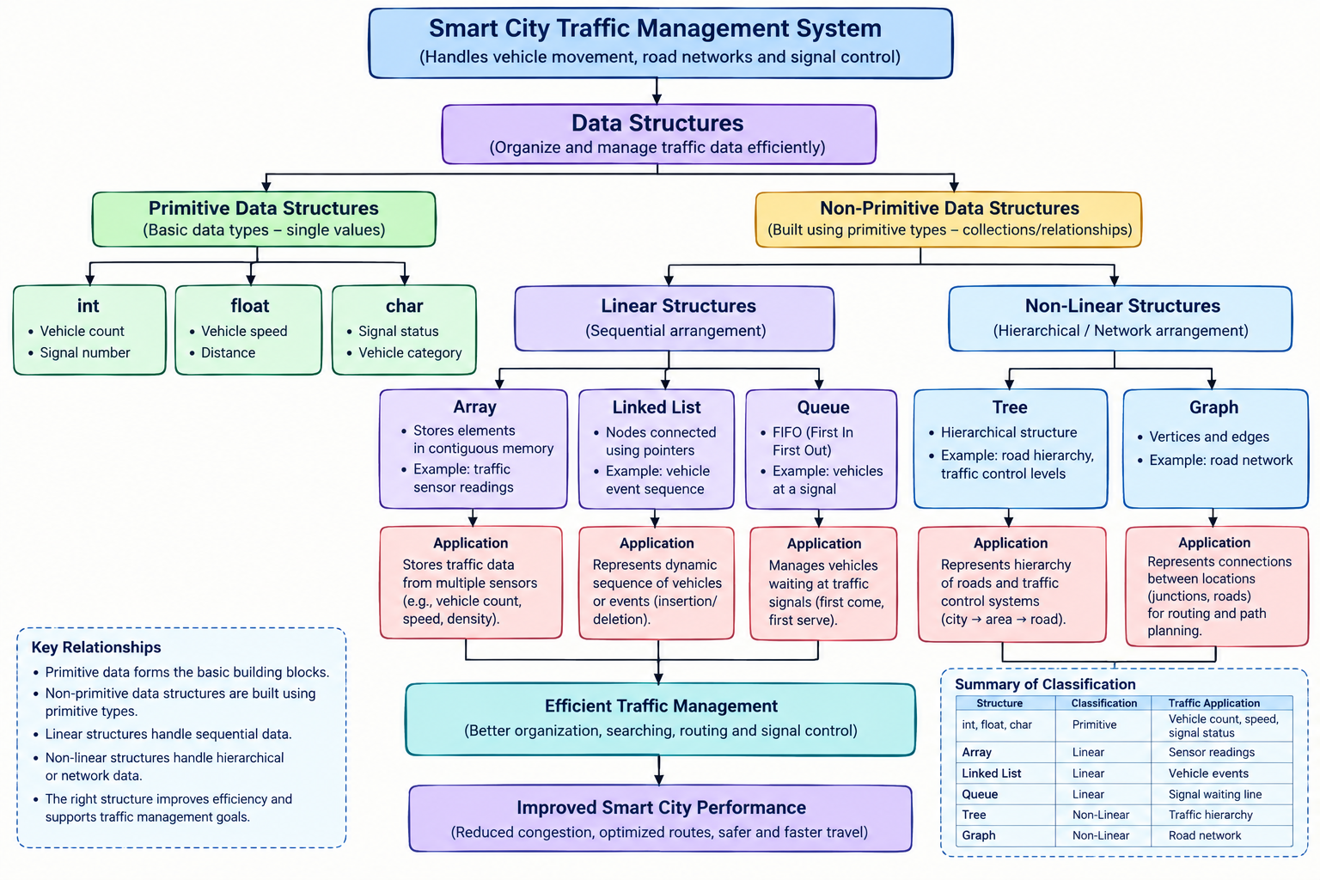

Explanation

Primitive Data Structures
Primitive data structures are the basic data types used to represent individual values.
Examples:
- int – vehicle count, signal number
- float – vehicle speed, distance
- char – signal status or vehicle category
They form the basic building blocks for more complex data structures.

Non-Primitive Data Structures
Non-primitive structures are constructed using primitive data types and can represent collections or relationships among data.

They are mainly classified into:
Non-Primitive Data Structures
│
├── Linear
│
└── Non-Linear

Linear Data Structures
In a linear data structure, elements are arranged in a sequential manner.

Array
An array stores elements in contiguous positions.

Traffic application:
An array can store traffic readings from multiple sensors.
Sensor 1 → Sensor 2 → Sensor 3 → Sensor 4

Linked List
A linked list consists of nodes connected using pointers.
Traffic application:
It can represent a changing sequence of vehicles or traffic events, where elements may be inserted or deleted dynamically.
Vehicle 1 → Vehicle 2 → Vehicle 3 → Vehicle 4

Queue
A queue follows FIFO (First In, First Out).
Traffic application:
It can represent vehicles waiting at a traffic signal.
Vehicle A → Vehicle B → Vehicle C
↑ ↑
First Last

Non-Linear Data Structures
Non-linear structures do not arrange elements in a single sequential order. They represent hierarchical or network relationships.
Tree
A tree represents hierarchical relationships.
Traffic application:
A tree can represent a hierarchy of roads or traffic-control levels.
City
│
┌──────┴──────┐
Area 1 Area 2
│ │
Roads Roads

Graph
A graph consists of vertices and edges.
It is highly suitable for representing road networks.
A -------- B
| |
| |
C -------- D

Here:
- Vertices → junctions/locations
- Edges → roads connecting them
Graphs can therefore represent connections between different locations in a city.

Relationship Between the Structures

DATA STRUCTURES
│
├───────────────┐
▼ ▼
Primitive Non-Primitive
│
┌───────┴───────┐
▼ ▼
Linear Non-Linear
│ │
┌──────┼──────┐ ┌─┴───┐
▼ ▼ ▼ ▼ ▼
Array Linked list Queue Tree Graph

Structure | Classification | Traffic Application
Integer | Primitive | Vehicle count
Float | Primitive | Vehicle speed
Array | Linear | Sensor readings
Linked List | Linear | Dynamic vehicle/event data
Queue | Linear | Vehicles waiting at signals
Tree | Non-Linear | Traffic hierarchy
Graph | Non-Linear | Road network
Structure | Classification | Traffic Application

Efficiency and Functionality
- Arrays provide fast indexed access.
- Linked lists allow flexible insertion and deletion.
- Queues are suitable for waiting-line processing.
- Trees efficiently represent hierarchical information.
- Graphs represent complex road-to-road relationships.
Therefore, selecting the appropriate structure according to the problem improves the organization and processing of traffic data.

Conclusion
A smart city traffic system uses both primitive and non-primitive data structures. Non-primitive structures are further classified into linear and non-linear structures. Arrays, linked lists and queues are useful for sequential traffic data, while trees and graphs are useful for hierarchical and network-based information. This classification helps select an appropriate structure for efficient traffic management.

